**CS657 Assignment 2 report**

Jiang Dong (819364904)

**INTRODUCTION:**

This program has 4 parts: Mad, Price, Share and FuzzyRules. In Price, I defined fuzzy set of price as VL, LO, MD, HI and VH. Similar as Price, I defined fuzzy set of Mad and Share respectively. The main process is defined in FuzzyRules as the following steps:

Step1: Take the crisp inputs, price and mad, and determine the degree to which these inputs belong to each of the appropriate fuzzy sets.

Step2: Rule evaluation.

Step3: Aggregate the rule output and defuzzification.

Step4: By using the result of the defuzzification to get the share to trade per day, then decide how many share to buy or sell based on how many share and money you have.

**Rule Base:**

The following fuzzy rules are used for this program:

Table 1. Fuzzy rules

|  |  |  |  |  |  |
| --- | --- | --- | --- | --- | --- |
|  | **VL** | **LO** | **MD** | **HI** | **VH** |
| **N** | BM | BF | SF | SM | SM |
| **Z** | BM | BF | DT | SF | SM |
| **P** | BM | BM | BF | SF | SM |

In table 1, the first row indicates the fuzzy set of price. The first column indicates the fuzzy set of mad. The rest of the content in the table is the output. In each rule, there are 2 inputs connected with “and”, then one output which indicates how many shares per day to buy or sell.

1. Rule1: If **price** is VL and **mad** is N then BM
2. Rule2: If **price** is LO and **mad** is N then BF
3. Rule3: If **price** is MD and **mad** is N then SF
4. Rule4: If **price** is HI and **mad** is N then SM
5. Rule5: If **price** is VH and **mad** is N then SM
6. Rule6: If **price** is VL and **mad** is Z then BM
7. Rule7: If **price** is LO and **mad** is Z then BF
8. Rule8: If **price** is MD and **mad** is Z then DT
9. Rule9: If **price** is HI and **mad** is Z then SF
10. Rule10: If **price** is VH and **mad** is Z then SM
11. Rule11: If **price** is VL and **mad** is P then BM
12. Rule12: If **price** is LO and **mad** is P then BM
13. Rule13: If **price** is MD and **mad** is P then BF
14. Rule14: If **price** is HI and **mad** is P then SF
15. Rule15: If **price** is VH and **mad** is P then SM

**PROGRAM FEATURES:**

1. **getPriceDegreeOfMembership()**

Take the crisp price and determine the degree to which this input belong to each of the appropriate fuzzy sets.

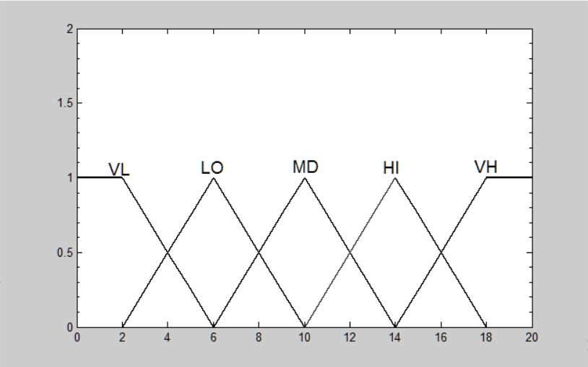

Fig1. Fuzzy set of price

1. **getMadDegreeOfMembership()**

Take the crisp mad and determine the degree to which the input ‘mad’ belong to each of the fuzzy sets.

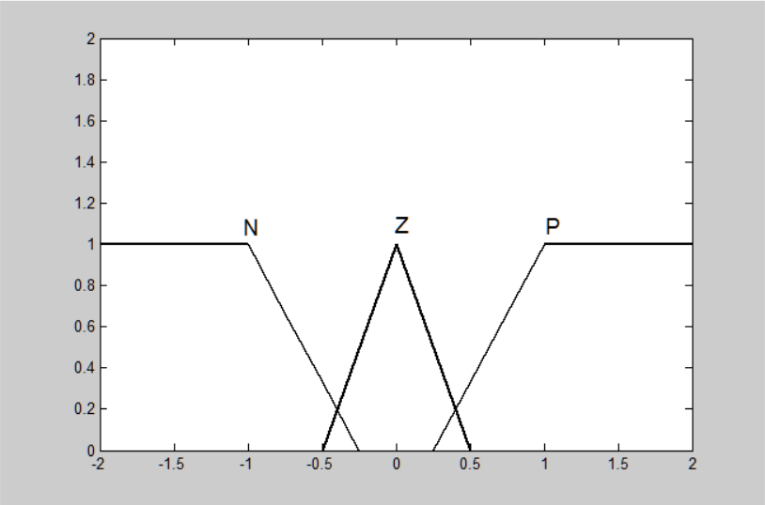

Fig2. Fuzzy set of mad

1. **fuzzyRules4Output()**

Get the fuzzy price and fuzzy mad and then evaluate each rule to get the degree for each fuzzy set of ‘share’.

1. **defuzzification()**

We already got the degree for each fuzzy set of ‘share’ and then we select some sample point to calculate the crisp share:

Table 2. Sample point for each fuzzy set of share

|  |  |  |  |  |  |
| --- | --- | --- | --- | --- | --- |
| BM | -800 | -700 | -600 |  |  |
| BF | -500 | -400 | -300 |  |  |
| DT | -200 | -100 | 0 | 100 | 200 |
| SF | 300 | 400 | 500 |  |  |
| SM | 600 | 700 | 800 |  |  |

For example if we get the degrees for the fuzzy set of ‘share’ are : BM(0.1), BF(0.2), DT(0.3), SF(0.4) and SM(0.5), then:

Crisp share =

**EXPERIMENTAL RUN:**

Run the program 10 times as the following settings:

Initial money to invest: $10,000

Maximum number of stock share buy or sell each time: 800

**EXPERIMENTAL RESULT:**

I had experimental run for 10 times. The following table shows the total money after 150 days for each time:

TABLE 3. Total money after 150 days

|  |  |  |  |  |  |  |  |  |  |
| --- | --- | --- | --- | --- | --- | --- | --- | --- | --- |
| 1 | 2 | 3 | 4 | 5 | 6 | 7 | 8 | 9 | 10 |
| 21338 | 13941 | 56033 | 113843 | 39506 | 18751 | 91804 | 21701 | 21435 | 48452 |

**DISCUSSION OF RESULT:**

According to the results, the minimal is 13941 and maximal is 113843, average is 44680, so based on the fuzzy rules I designed, we can get the profit and the average rate of profit is 346%. However, the profit fluctuates up and down dramatically, for example, the minimal is just 13941, the profit rate is just 39.4%; the maximal is 113843, the profit rate is as high as 1038%, so I need to improve the fuzzy rules to make the performance stable.

**CONCLUSION:**

As I discussed above, the fuzzy rules I designed can be used to get profit. However, the profit fluctuates dramatically. Therefore, I need to tune the system to make the performance of the system stable. The following method can be used to tune the system:

1. Adjust the ranges of input and output variables for better performance.
2. Adjust the fuzzy rules, for example, modify the 4th rule as:

Rule4: If **price** is HI and **mad** is N then SF.

Then evaluate the system performance, and readjust the rules based on the new performance.

1. Provide sufficient overlap between adjacent set (25% to 50%)
2. Adjust the rule execution weights for better performance.